Exercise 1: Logging Error Messages and Warning Levels

Dependencies (pom.xml)
<dependency>
<groupId>org.slf4j</groupId>
<artifactId>slf4j-api</artifactId>
<version>1.7.30</version>
</dependency>
<dependency>
<groupId>ch.qos.logback</groupId>
<artifactId>logback-classic</artifactId>
<version>1.2.3</version>
</dependency>

Source Code

LoggingExample.java
import org.slf4j.Logger;
import org.slf4j.LoggerFactory;
public class LoggingExample {
private static final Logger logger =
LoggerFactory.getLogger(LoggingExample.class);
public static void main(String[] args) {
logger.error("This is an error message");
logger.warn("This is a warning message");
}
}

Output
13:22:01.604 [main] ERROR LoggingExample - This is an error message
13:22:01.612 [main] WARN LoggingExample - This is a warning message
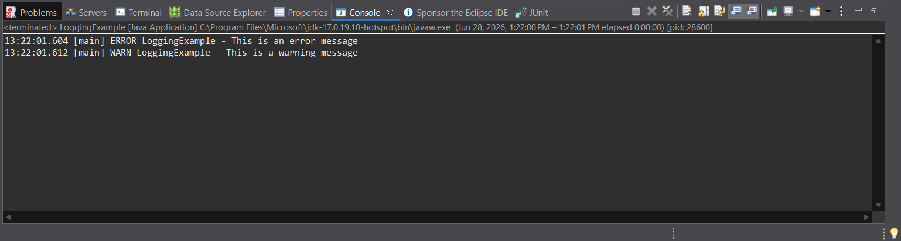
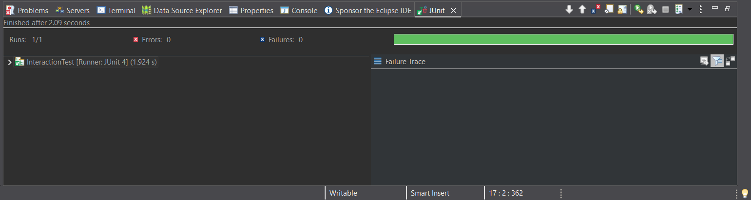

Result
The SLF4J logging framework successfully logged both ERROR and WARN level messages using Logback as the logging implementation. The application executed successfully, and the log messages were displayed correctly in the Eclipse Console.

